# **附件2**

# **岳阳现代服务职业学院优秀教案展示**

# 51763f12a9b6d48d4a9243f7bbdeda3 331410db459d13ad721ed856d5e72f8

# 6e9ed3e566322962e48e31d0d944550 8f84175faf46dfa97996b6f2df8bd81

# 634ac3a4c8869a65f9f229cfb0e03e6 4ff8e2002fb569eaeeb7a274117410d

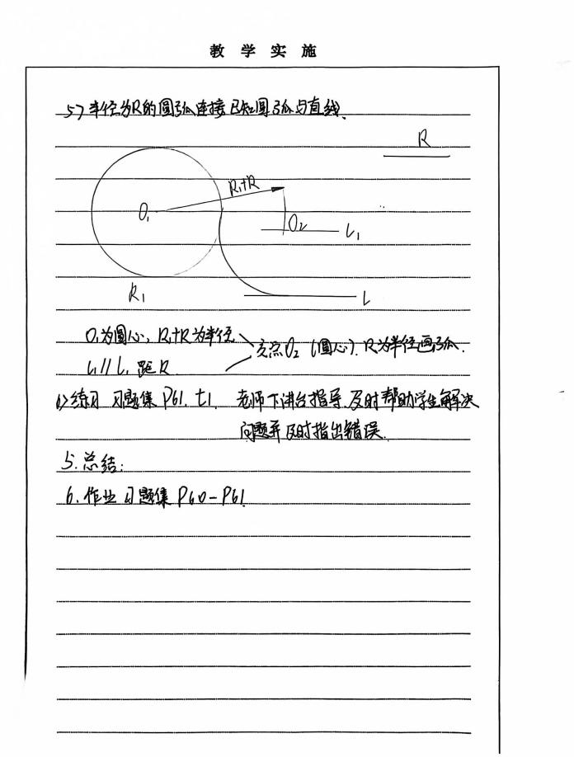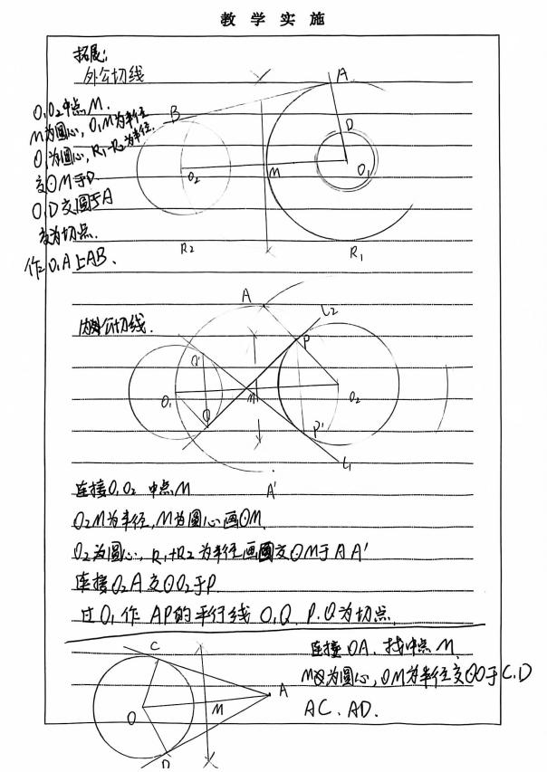

# **ce4dc518268d9c4b78acdaa1255fe78 d9ed4ba3d2e02cbe5ac2acfe9b35e80**

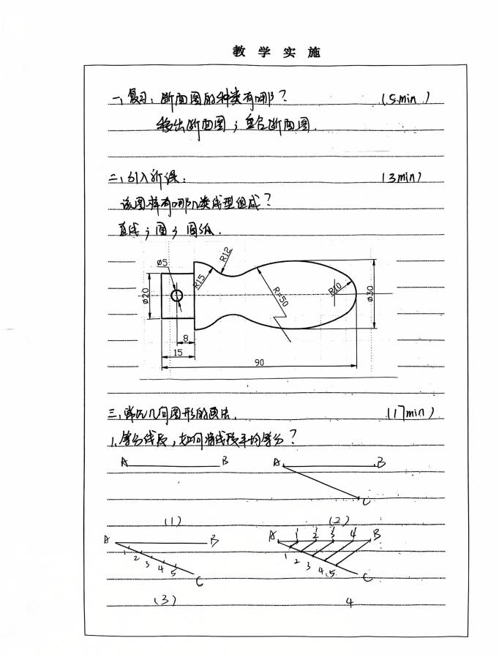 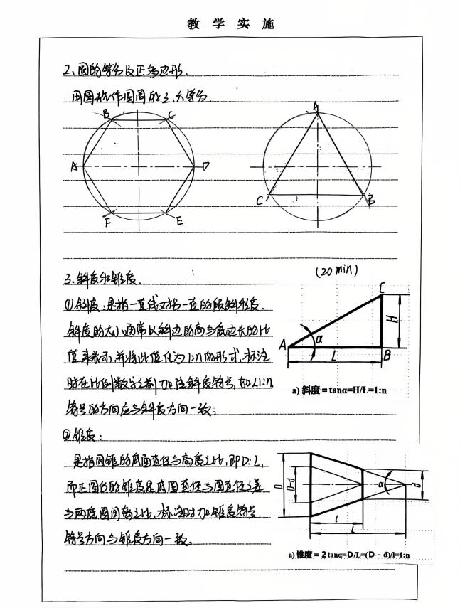

# 0df277d9c890480e9298567a1f13fa3 f4ea73eab083901aaa597ca7810bf33

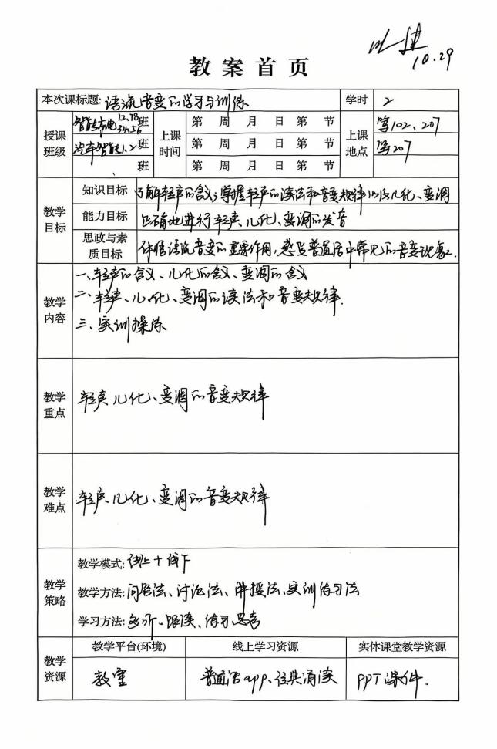 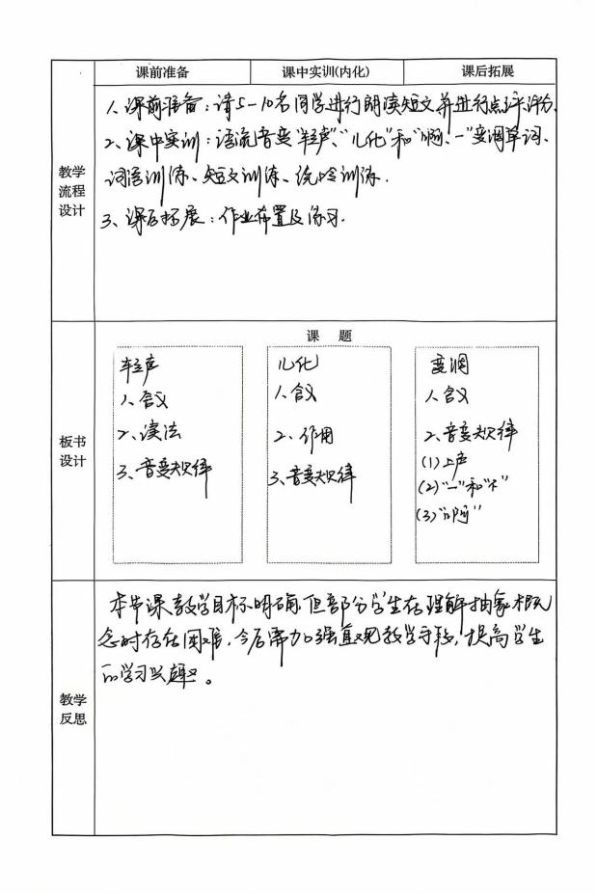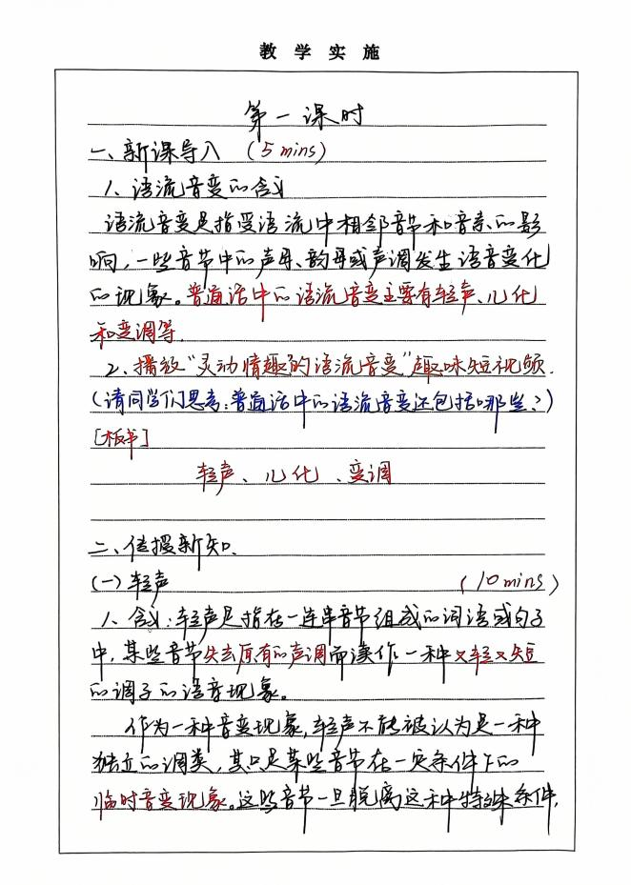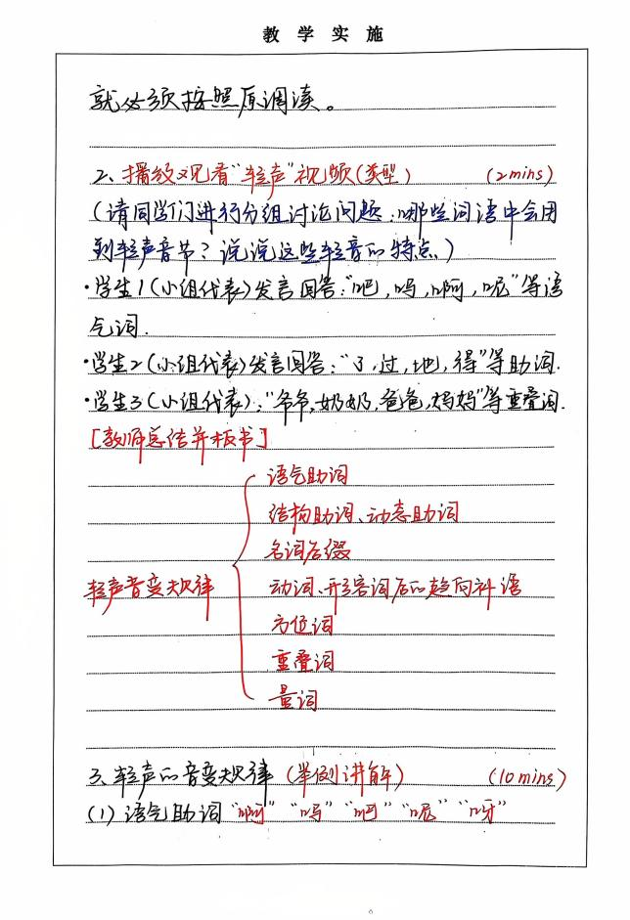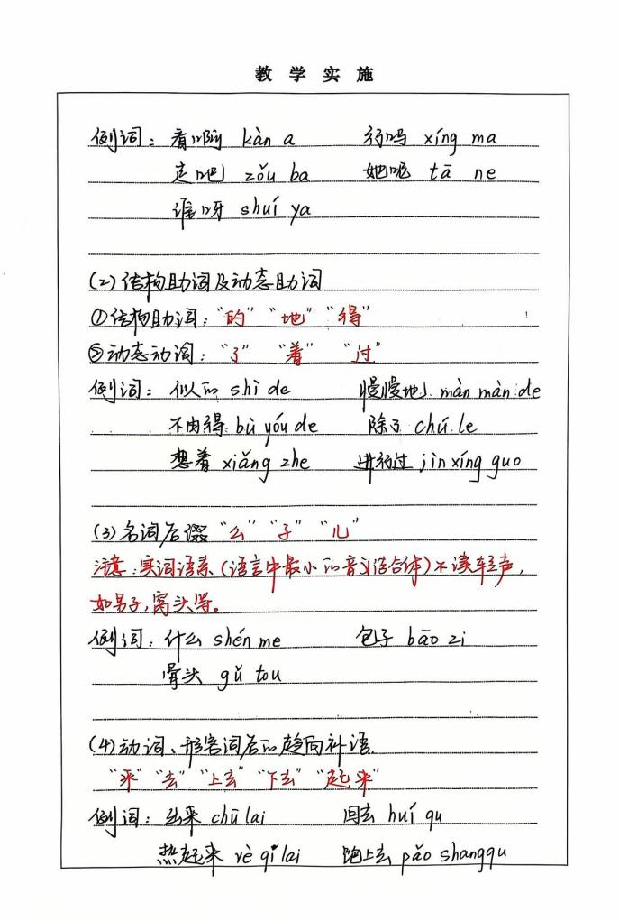 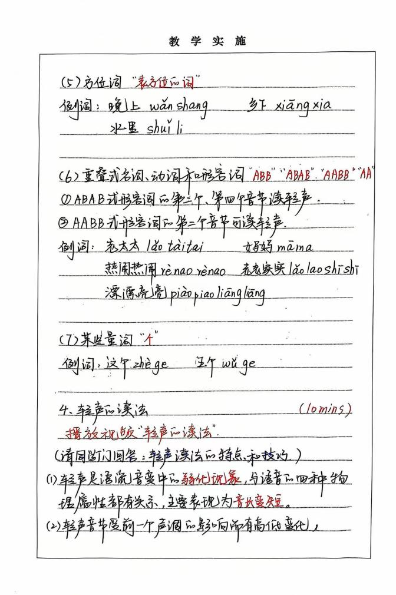

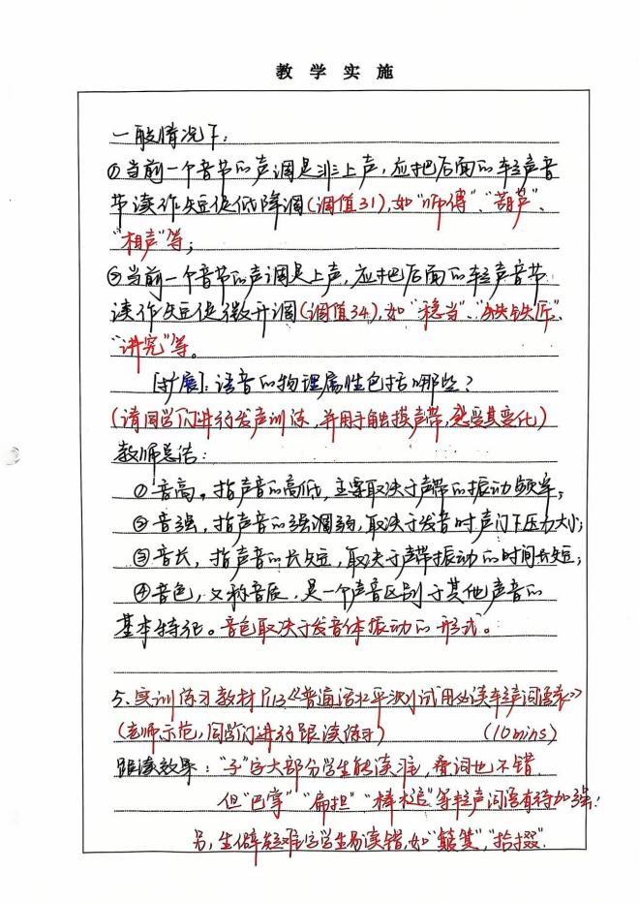 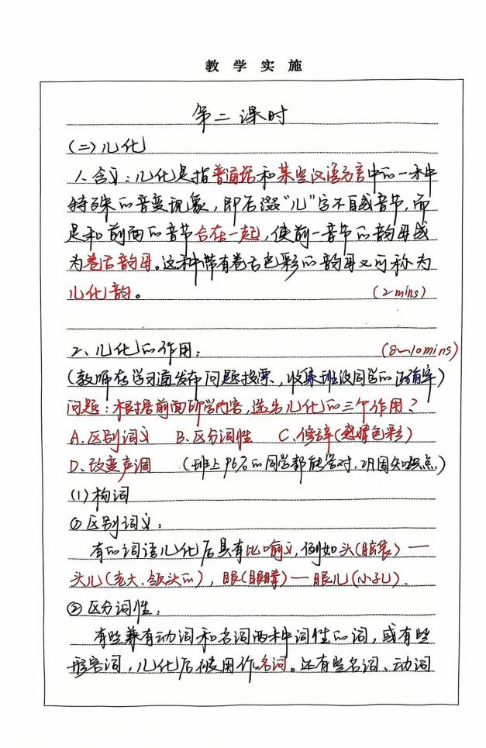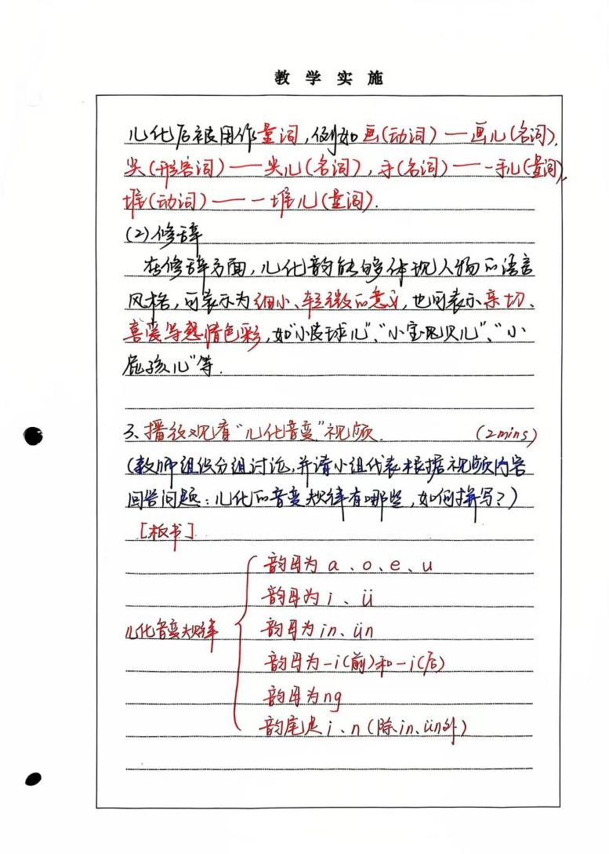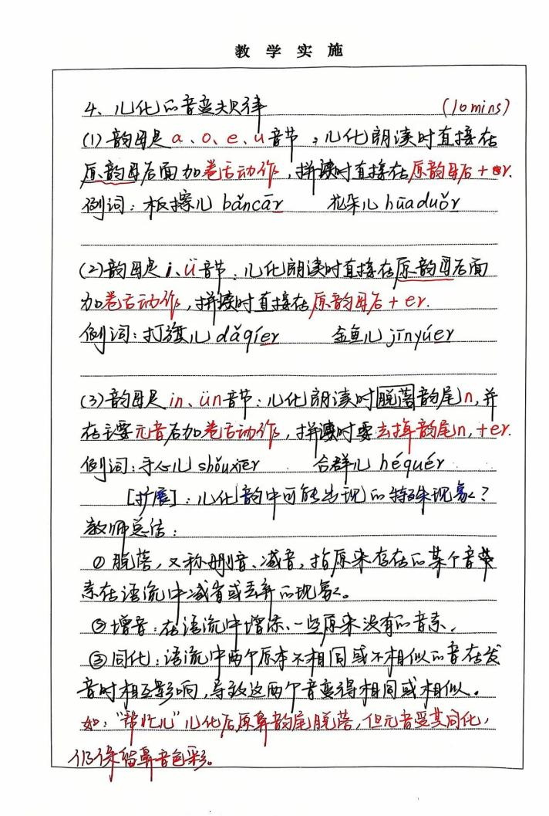

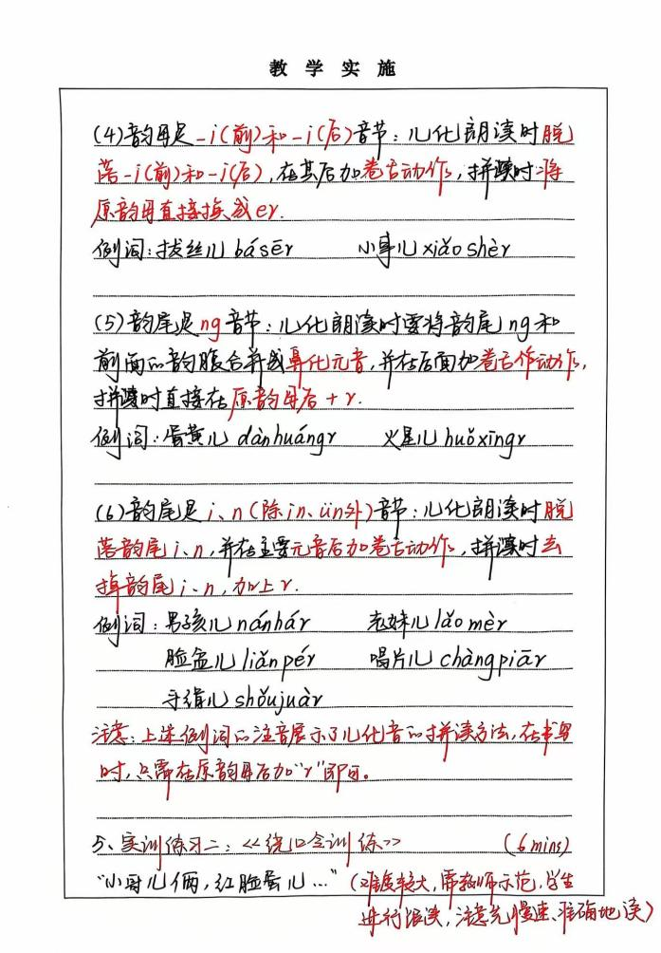 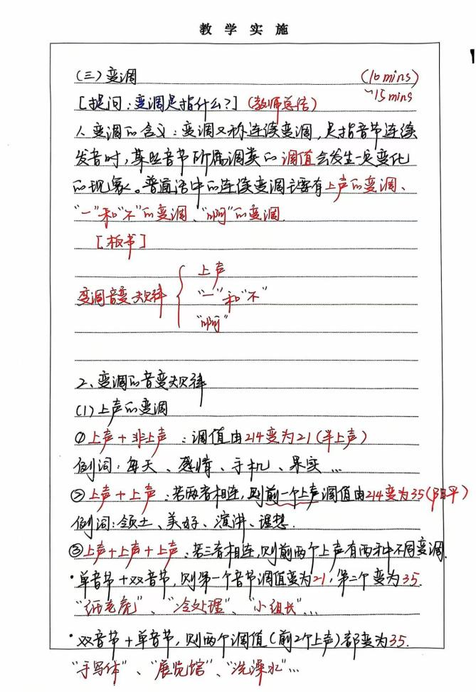

# 13 14